Database Coursework Part 1
HLUM HTET AUNG
40841063

Table of Contents
Assessment Cover Sheet 3
Task 1 – Part A 4
Database attributes 4
Entity Relation Diagram 5
Data types 6
First Normalization 6
Second Normalization 6
Third Normalization 7
ERD Keys and Relations 7
Keys 8
Relations 9
Task 2 – Part B 10
Scenario 10
SQL Query 1: Test event summary 10
SQL Query 2: Employee of the year 10
SQL Query 3: Recently qualified traffic controllers 10
SQL Query 4: Airplane safety check 11
SQL Query 5: Technician expertise summary 11
Query Test Plan 11
Conclusion 12

Assessment Cover Sheet
MODULE NUMBER: XL003332_2025-6_TR3_001 - Database Systems (SET09801/SET11801) TR3
TRIMESTER AND ACADEMIC YEAR: 2025-2026
I declare that, except where explicit reference is made to the contribution of others*, that this assignment is the result of my own work and has not been submitted for any module or programme degree at the Edinburgh Napier University or any other institution. This is in accordance with Edinburgh Napier University’s Academic Integrity Regulations.

*IMPORTANT: Please declare here whether you have used Artificial Intelligence (AI) tools, and to what extent:
☐ No, I have not used such tools
☒ Yes, I have used such tools
If you answered YES here, please, in around 150 words, describe how (and at which points) you have used such tools to support your completion of this assessment:
I have used AI tools to check grammar for my paragraphs, with careful practices not to change any original meaning or context of my text. As English is not my first language, there are some minor grammar mistakes in my report. To fix these, AI tools Grammarly and Quill bot are used in order to improve my writing and make it more academic.

NAME: HLUM HTET AUNG
STUDENT NUMBER: 40841063

Task 1 – Part A

Database attributes
The primary purpose of databases for Edinburgh Airport International entities is to organize the data and information according to the scenario. The data are split into multiple tables for a clearer view. According to the airport structure, employees, and daily work flow the attributes are taken into consideration as a first task. Regarding the scenario the attributes for the first draft after the scenario breakdown are –
- Plane attributes
  - Airplane registration number
  - Plane model number
  - Capacity
  - Weight
- Technician attributes
  - Name
  - SSN
  - Address
  - Phone number
  - Salary
  - Union number
- Traffic controller attributes
  - Name
  - SSN
  - Address
  - Phone number
  - Salary
  - Last medical examination date
  - Union number

- Airworthy tests
  - Name
  - Test number
  - Registration number
  - Technician’s SSN
  - Date
  - Hours spent
  - Score received
This is the foundational step where the airport scenario and workflow were broken down, and possible attributes are drawn out.

Entity Relation Diagram
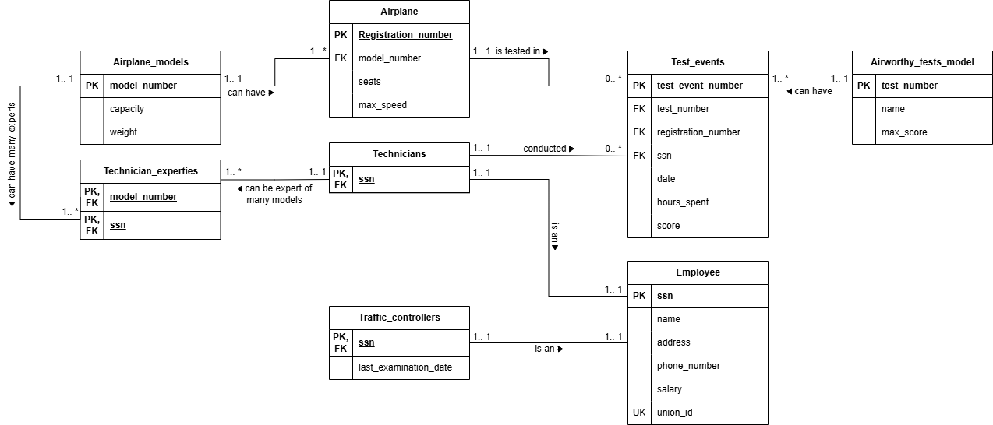
Figure 1 Airport Database ERD
The entity relation diagram of the airport database can be seen above. This is the finalized version of the diagram with attributes separated into multiple entities. To get here 3 stages of finalization were done.

Data types
The data types for attributes in the ERD are –
- Model number – VARCHAR
- Capacity – INT
- Weight – INT
- Registration number – INT
- Seats – INT
- Max speed – FLOAT
- Test event number – VARCHAR
- Test number – VARCHAR
- Date – Date/Time
- Hours spent – FLOAT
- Score – FLOAT
- SSN – INT
- Name – VARCHAR
- Address – VARCHAR
- Phone number – VARCHAR
- Salary – FLOAT
- Union ID - VARCHAR

First Normalization
For 1NF, attributes in the first draft are restructured. Primary key was assigned to each unique attribute in every entity, there are no overlapping columns in a single table, and there will be only single value per cell.

Second Normalization
As 1NF is achieved, the ERD moved on to second normalization. The attributes in each entity are fully dependent on primary key. The ERD above achieve this by isolating these attributes into lookup tables with single primary keys and reference those models with a foreign key.

Third Normalization
After both 1NF and 2NF, the 3NF is carried out on Technicians and Traffic controllers table in the draft design. This is because these two tables contain shared employment attributes such as name, phone number, and address, where these are separated into master Employee table that directly connect employee social security numbers to the specialized tables of technicians and traffic controllers.

ERD Keys and Relations
This part will discuss the keys and relations between different entities for the airport database. In this design, tables are separated into four main tables, two lookup tables, and two composite tables. The table categories are –
- Main Tables
  - Employee
  - Airplane
  - Test events
- Sub-tables (Employee)
  - Technicians
  - Traffic controllers
- Lookup Tables
  - Airplane models
  - Airworthy tests model
- Composite Tables
  - Technician expertise

Keys
In every table there are primary keys and foreign keys and some also contain unique keys for distinct union number of an employee. This section will explain the usage of keys on each table. The keys in each table are –
- Employee Table
  - Social security number as a primary key unique identifier
  - Union number/id as a unique key as each employee is part of a union and has different union numbers
- Airplane table
  - The airplane table has registration number as a primary key
  - Model number is a foreign key that links to airplane models lookup table
- Test events
  - The test event number is added as dedicated column for primary key (surrogate key)
  - Test number act as foreign key to airworthy tests model
  - Registration number is a foreign key to airplane table
  - Social security number is a foreign key to technician that performed the test
- Technicians
  - The technicians table has social security number as primary key and foreign key as it is subtype table that connects employee with one-to-one (natural key)
- Traffic controllers
  - Like technicians this table also has SSN as primary key and foreign key as it is sub-table of employee (natural key)
- Airplane models
  - This table has model number as a primary key as it is used to identify each model uniquely
- Airworthy test model
  - This table uses surrogate key test numbers as primary key to identify distinct test models

- Technician expertise
  - This table is a bridge between airplane models and technicians who are experts in those models and has model number and SSN as both primary and foreign key since it connects two different tables

Relations
This section of the report will explain the relations between tables in the airport database. The relation between the tables is –
- (Airplane models 1:1--------1: * Airplane) – an airplane model can have many airplanes, but an airplane must have one airplane model
- (Airplane 1:1-------0: * Test events) – an airplane can have optionally one or more tests, but each test events must have an airplane
- (Test events 1: *-------1:1 Airworthy test model) – an airworthy test model can have many test events, but one test event must have one airworthy test model
- (Test events 0: *-------1:1 Technicians) – a test even must have one technician that conduct the test, but a technician may conduct zero, one, or more tests
- (Technicians 1:1-------1:1 Employee) – technicians and employee tables are one-to-one connected
- (Traffic controllers 1:1-------1:1 Employee) – traffic controllers and employee tables are one-to-one connected
- (Technicians 1:1-------1: * Technician expertise) – a technician can be expert at many models
- (Airplane models 1:1-------1: * Technician expertise) – an airplane model can have one or more expert technicians

Task 2 – Part B

Scenario
Using the data set, many queries can be made to gain insight into the airport and the employees’ performance. For example, if airline management wants to get the high-performing technicians, they can use employee table via technicians and make queries by combining with test events table to see the employees with most tests performed. Below will be the queries that can help the management gain insight from the airport data.
Note*: These queries are the original planned queries. In part 2, with the need for other insights the number of queries may expand. For example, if a query shows airplane safety check, there may be a need to examine why some planes don’t meet the expected average score or lower than average score received in the past.

SQL Query 1: Test event summary
This query aims to get the summary from three main tables – Test events, Airplane, and Employees via Technicians tables – to summarize testing data. The query will include approximately 4-5 columns, giving insights on airplane model number, registration number, number of tests conducted using count function, total number of test hours using sum function, and average test score using average function. After this query the management can find out how many test events have occurred in the airport and which plane model has the best air-worthy score.

SQL Query 2: Employee of the year
This query will use two two tables – technician via employee table and test events – to find out the employee with the best performance. The query will output 4 columns, employee’s name, SSN, and the number of test events the employee as well as the year of the tests. By doing so the company can find out the best performing employees of each year and award them accordingly.

SQL Query 3: Recently qualified traffic controllers
This query will be a mini query that will show the traffic controllers that had very recent medical examination. The results of this query can help management determine which traffic controller is the most fit for important tasks.

SQL Query 4: Airplane safety check
This query will use correlated query to check the average score from the test events first and compare the subquery result with main query’s test score to find if the plane is above the average expected score and is fit for flight. This can ensure management select safe planes for passenger transport, reducing the risk of accidents. The query is expected to return 6 columns – airplane model from model table, registration number from airplane table, technician name of the one who conducted the test, technician’s SSN, the score achieved for that specific plane’s latest test event, and the average score of the plane model from previous tests. By comparing latest test score with average historical scores management can ensure if the plane is safe to fly or not.

SQL Query 5: Technician expertise summary
This query will return the technician’s SSN and their related expertise for plane models with group by function so the management can find out which technician is expert for which models.

Query Test Plans
To ensure the queries give expected result, testing will be carried out to find expected results first. This section will provide the testing solutions for each query to ensure they return expected results.
Query No | Sample Data | Expected result
- Test event summary | Model number  Number of tests  Registration number  Total number of test hours  Average test score | (model number, registration number, test number, total test hours, average score)
- Employee of the year | Employee’s name  SSN  Total test events per year | (SSN, name, total tests per year)
- Recently qualified traffic controllers | Name  SSN  Last medical exam date | (SSN, name, last examination date)
- Airplane safety check | Plane model  Registration number  Technician name  SSN  Achieved score  Average score | (model number, registration number, technician name, SSN, achieved score, average score)
- Technician expertise summary | SSN  Model number | (SSN, model number)
Table 1 Query Test Plan

Conclusion
In task 1-part A, this report contains the explanation of ERD design – entities, attributes, and relationships – between each table. The report then continues to mention first normalization, second normalization, and third normalization of the entities in the database. In task 2-part B, the report explains the queries that will be made to report to the management about the test event summary, employee of the year, recently qualified traffic controllers, airplane safety check, and technician expertise summary.

